Visual Glove Testing/Inspection Process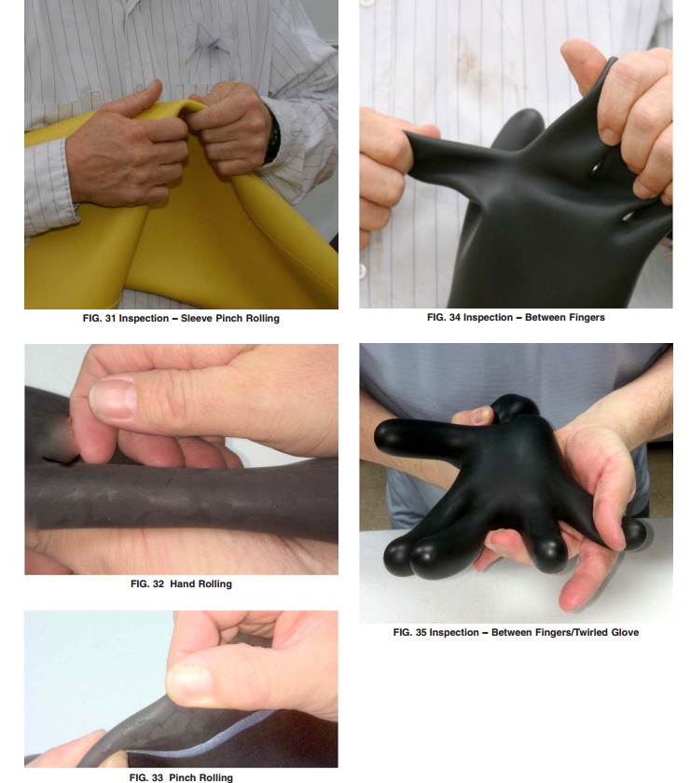
Visual Glove Testing/Inspection Process

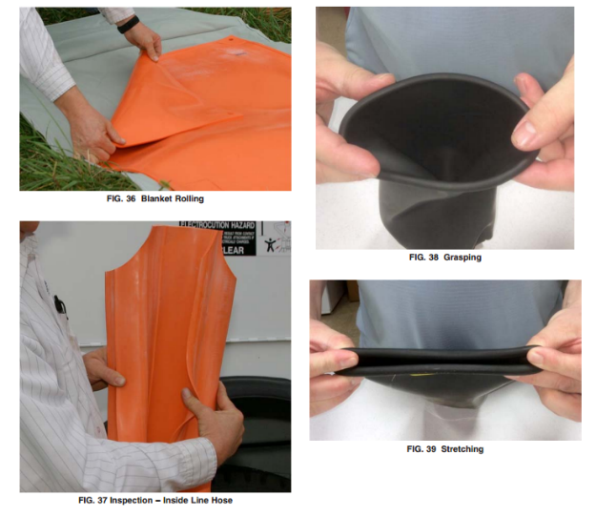

Visual Glove Testing/Inspection Process

