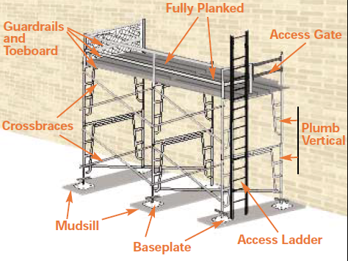
Scaffolding at least 10 ft. away from overhead power lines?
Is scaffolding plumb and level and cross bracing crosses at center?
Are the scaffolding picks capable of support the intended load? (usually decaled on the side of the pick)
Is there means for safe access? (cross bracing is not considered a means for access)
Verify the absence of bends, cracks, rust welding splatter, broken welds, and non-compatible parts in metal components.
Are the legs, posts, frames, and uprights on baseplates or casters?
If on soft ground, are mudsills in place under the baseplates. (min 2 in. x 10in. x 10 in. )
Is the scaffolding guarded by a top rail, mid-rail and toe board? (If the scaffolding work level is ≥ 6ft.)
Verify the planks are absent of cracks, splits, end splits, large loose knots, warping, mold, separated laminate, coatings that obscure defects.
Verify the plank is on the frame and secured from uplift.
Are casters locked in place to prevent movement?
Verify the planks are close together.
Is the front of a platform not more than 14 inches from the face of the work? If not, a guardrail system needs to be installed or a personal fall arrest system is to be used.
Are outriggers, bracing, tie-ins or guying being used to prevent tipping for scaffolds higher than 4 x the base width? (Outriggers, when used, may be considered a part of the base dimension.)
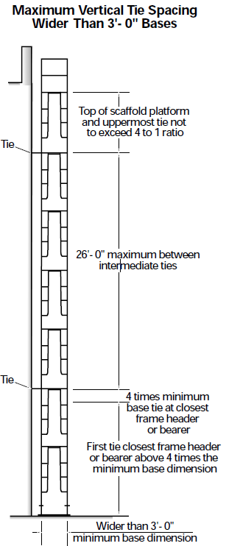
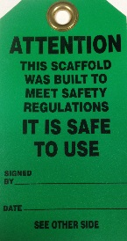 | Green Tag – This scaffold was built to MIOSHA scaffold regulations; It is Safe to use.
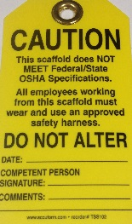 | Yellow Tag - This scaffold does not meet MIOSHA scaffold regulations; safety harness with shock absorbing lanyard shall be worn. Scaffolds that cannot be equipped with standard top rail, mid rail and toeboard shall display a yellow tag.
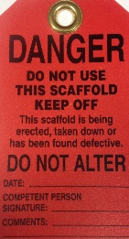 | Red Tag - This scaffold is not complete; Do Not Use. Scaffolds being constructed, torn down or which are found to be defective shall be marked with a red tag.

