UNIVERSITY OF MICHIGAN PERSONAL PROTECTIVE EQUIPMENT GUIDELINE
CERTIFICATION OF HAZARD ASSESSMENT

Job Title: | Date:
Department: | Supervisor:
Location: | Analysis By:
Employee Name(s): | Signature:

Task(s) | Potential Hazard(s) | PPE Recommended

SUPPLEMENT TO THE HAZARD ASSESSMENT

Table I. Eye and Face Protection Selection Chart

TYPE | HAZARD(S) | ASSESSMENT SEE NOTE (1) | PROTECTOR TYPE  (refer to graphic below) | PROTECTORS |  | LIMITATIONS | NOT RECOMMENDED
I M P A C T | Chipping, grinding, machining, masonry, work, riveting, and sanding | Flying fragments, objects, large chips, particles, sand, dirt, etc. | B, C, D, E, F, G,  H, I, J, K, L, N | Spectacles, goggles, face shields  SEE NOTE (1) (3) (5) (6)  (10)  For severe exposures add N. |  | Protective devices do not provide unlimited protection.  SEE NOTE (7) | Protectors that do not provide protection from side exposure  SEE NOTE (10)  Filter or tinted lenses that restrict light transmittance, unless it is determined that a glare hazard exists. Refer to OPTICAL RADIATION.
H E A T | Furnace operations, pouring, casting, hot dipping, gas cutting, and welding | Hot sparks | B, C, D, E, F, G,  H, I, J, K, L, N | Face shields, goggles, spectacles  *For severe exposure add N.  SEE NOTE (2) (3) |  | Spectacles, cup and cover type goggles not provide unlimited protection.  SEE NOTE (2) | Protectors that do not provide protection from side exposure
H E A T |  | Splash from molten metals | *N | *Face shields worn over goggles H, K |  | --- | Protectors that do not provide protection from side exposure
H E A T |  | High temperature exposure | N | Screen face shields, reflective face shields  SEE NOTE (2) (3) |  | SEE NOTE (3) | Protectors that do not provide protection from side exposure
C H E M I C A L | Acid & chemicals handling, degreasing, plating | Splash | G, H, K,  *N | Goggles, eyecup, and cover types  * For severe exposure, add N. |  | Ventilation should be adequate but well protected from splash entry. | < None >
C H E M I C A L | Acid & chemicals handling, degreasing, plating | Irritating mists | G | Special purpose goggles |  | SEE NOTE (3) | < None >
D U S T | Woodworking, buffing, general dusty conditions | Nuisance dust | G, H, K | Goggles, eyecup, and cover types |  | Atmospheric conditions and the restricted ventilation of the protector can cause lenses to fog. Frequent cleaning may be required. | < None >
O P T I C A L  R A D I A T I O N | Welding: Electric Arc |  | O, P, Q | TYPICAL FILTER LENS SHADE | PROTECTORS | Protection from optical radiation is directly related to filter lens density.  SEE NOTE (4)  Select the darkest shade that allows adequate task performance. | Protectors that do not provide protection from optical radiation.  SEE NOTE (4)
O P T I C A L  R A D I A T I O N |  |  | O, P, Q | 10 – 14 | Welding Helmets or Welding  Shields
O P T I C A L  R A D I A T I O N |  |  | O, P, Q | SEE NOTE (9)
O P T I C A L  R A D I A T I O N | Welding:  Gas Cutting  Torch Brazing |  | J, K, L, M, N, O, P, Q | 4 – 8  3 – 6  3 – 4 | Welding Goggles  or  Welding Shields | SEE NOTE (3)
O P T I C A L  R A D I A T I O N | Torch Soldering |  | B, C, D, E, F, N | 1.5 – 3 | Spectacles or  Welding Faceshield | SEE NOTE (3) | < None >
O P T I C A L  R A D I A T I O N | Glare |  | A, B | Spectacle  SEE NOTE (9) (10) |  | Shaded or special Purpose lenses as suitable  SEE NOTE (8)

Notes to Table I. Eye and Face Protection Selection Chart:
- Care should be taken to recognize the possibility of multiple and simultaneous exposure to a variety of hazards. Adequate protection against the highest level of each of the hazards should be provided. Protective devices do not provide unlimited protection.
- Operations involving heat may also involve light radiation. As required by the standard, protection from both hazards must be provided.
- Faceshields should only be worn over primary eye protection (spectacles or goggles).
- As required by the standard, filter lenses must meet the requirements for shade designations in 1910.133(a)(5). Tinted and shaded lenses are not filter lenses unless they are marked or identified as such.
- As required by the standard, persons whose vision requires the use of prescription (Rx) lenses must wear either protective devices fitted with prescription (Rx) lenses or protective devices designed to be worn over regular prescription (Rx) eyewear.
- Wearers of contact lenses must also wear appropriate eye and face protection devices in a hazardous environment. It should be recognized that dusty and/or chemical environments may represent an additional hazard to contact lens wearers.
- Caution should be exercised in the use of metal frame protective devices in electrical hazard areas.
- Atmospheric conditions and the restricted ventilation of the protector can cause lenses to fog. Frequent cleansing may be necessary.
- Welding helmets or faceshields should be used only over primary eye protection (spectacles or goggles).
- Non-sideshield spectacles are available for frontal protection only, but are not acceptable eye protection for the sources and operations listed for "impact."
- Ventilation should be adequate, but well protected from splash entry. Eye and face protection should be designed and used so that it provides both adequate ventilation and protects the wearer from splash entry.
- Protection from light radiation is directly related to filter lens density. See note (4). Select the darkest shade that allows task performance.

PROTECTOR TYPES (from Table 1 above):

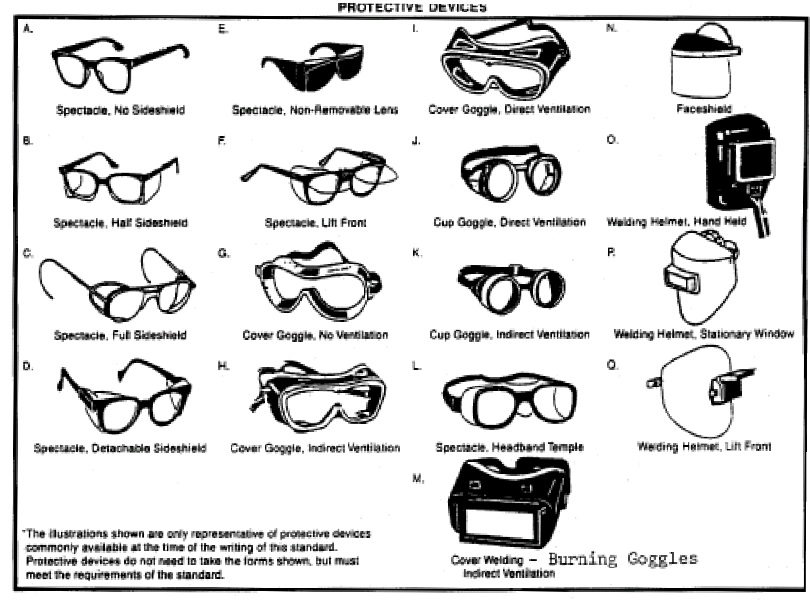

Table II. Filter Lenses for Protection Against Radiant Energy

Operations | Electric Size ¹/32  in. | Arc Current (amps) | Minimum* Protective Shade
Shielded metal arc welding | Less than 3 | Less than 60 | 7
Shielded metal arc welding | 3 - 5 | 60 - 160 | 8
Shielded metal arc welding | 5 - 8 | 160 - 250 | 10
Shielded metal arc welding | More than 8 | 250 - 550 | 11
Gas metal arc welding and flux cored arc welding | --- | Less than 60 | 7
Gas metal arc welding and flux cored arc welding | --- | 60 - 160 | 10
Gas metal arc welding and flux cored arc welding | --- | 160 - 250 | 10
Gas metal arc welding and flux cored arc welding | --- | 250 - 500 | 10
Gas Tungsten arc welding | --- | Less than 50 | 8
Gas Tungsten arc welding | --- | 50 - 150 | 8
Gas Tungsten arc welding | --- | 150 - 500 | 10
Air carbon | Light | Less than 500 | 10
Arc cutting | Heavy | 500 – 1,000 | 11
Plasma arc welding | --- | Less than 20 | 6
Plasma arc welding | --- | 20 - 100 | 8
Plasma arc welding | --- | 100 - 400 | 10
Plasma arc welding | --- | 400 - 800 | 11
Plasma arc cutting | Light** | Less than 300 | 8
Plasma arc cutting | Medium** | 300 - 400 | 9
Plasma arc cutting | Heavy** | 400 - 800 | 10
Torch soldering | --- | --- | 2
Torch brazing | --- | --- | 3
Carbon arc welding | --- | --- | 14

Operations | Plate Thickness (inches) | Plate Thickness (mm) | Minimum* Protective Shade
Gas Welding: | --- | --- | ---
Light | Under ¹/₈ | Under 3.2 | 4
Medium | ¹/₈ to ¹/₂ | 3.2 to 12.7 | 5
Heavy | Over ¹/₂ | Over 12.7 | 6
Oxygen Cutting: | --- | --- | ---
Light | Under 1 | Under 25 | 3
Medium | 1 to 6 | 25 to 150 | 4
Heavy | Over 6 | Over 150 | 5
* As a rule of thumb, start with a shade that is too dark to see the weld zone. Then go to a lighter shade which gives sufficient view of the weld zone without going below the minimum. In oxyfuel gas welding or cutting where the torch produces a high yellow light, it is desirable to use a filter lens that absorbs the yellow or sodium line in the visible light of the (spectrum) operation.
** These values apply where the actual arc is clearly seen. Experience has shown that lighter filters may be used when the arc is hidden by the work piece.

