**Laser Safety Supervisor: Phone:**

**Class 3B Laser Controlled Area**

**Avoid direct eye exposure to beam.**

**Restricted Area, Authorized Personnel Only**

**Laser Eye Protection: OD ≥**

**Laser Type:**

**Wavelength: nm**

**Power/Energy:**

**WARNING**

**!**

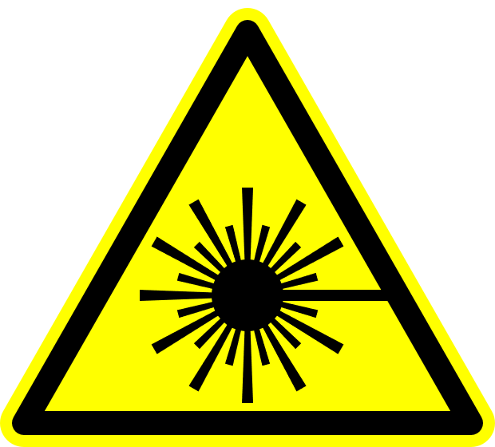

**Radiation and Laser Safety Emergency Contact: (614) 561-7969**

**Laser Safety Supervisor: Phone:**

**Class 4 Laser Controlled Area**

**Avoid eye or skin exposure to direct or scattered radiation.**

**Do Not Enter When Light is Illuminated**

**Laser Eye Protection: OD ≥**

**Laser Type:**

**Wavelength: nm**

**Power/Energy:**

**Radiation/Laser Safety Emergency Contact: (614) 561-7969 (24/7)**

**WARNING**

**!**



**Radiation and Laser Safety Emergency Contact: (614) 561-7969**

**Laser Repair in Progress**

**Radiation/Laser Safety Emergency Contact: (614) 561-7969 (24/7)**

NOTICE

**Radiation and Laser Safety Emergency Contact: (614) 561-7969**

**Class 4 Laser Controlled Area**

**Avoid eye or skin exposure to direct or scattered radiation.**

**Do Not Enter When Light is Illuminated**

**Laser Eye Protection: OD ≥**

**Laser Type:**

**Wavelength: nm**

**Power/Energy:**

**Radiation/Laser Safety Emergency Contact: (614) 561-7969 (24/7)**

**DANGER**

**!**



**Radiation and Laser Safety Emergency Contact: (614) 561-7969**

**Laser Safety Supervisor: Phone:**