Acutely Toxic Chemicals
Standard Operating Procedure
Revision Date: 7/5/2022

Laboratory Director (LD) Approval is Required Prior to Performing this Procedure
This standard operating procedure (SOP) outlines the handling and use of acutely toxic chemicals. Review this document and supply the information required in order to make it specific to your laboratory. In accordance with this document, laboratories should use appropriate controls, personal protective equipment, and disposal techniques when handling acutely toxic chemicals. All laboratory workers must read and understand the Laboratory Emergencies SOP prior to commencing any work in a laboratory.

Description [Provide additional information as it pertains to your research protocol]

Acute toxicity is defined by MIOSHA as adverse effects occurring following oral or dermal administration of a single dose of a substance, or multiple doses given within 24 hours, or an inhalation exposure of 4 hours. MIOSHA stipulates additional employee protection for work with chemicals that exhibit a high degree of acute toxicity.
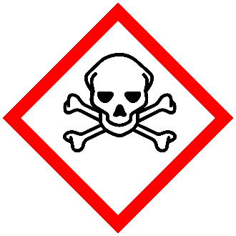
A substance with a high degree of acute toxicity is considered any chemical substance that meets one or more of the following Globally Harmonized System (GHS) hazard classifications. Reference the Safety Data Sheet (SDS) for GHS information specific to your substance.
- Acute toxicity, dermal Category 1, 2
- Acute toxicity, inhalation Category 1, 2
- Acute toxicity, oral Category 1, 2

GHS Pictogram for acutely toxic substances

Process [Write the steps for using the chemical in your research protocol]

Potential Hazards [Provide additional information as it pertains to your research protocol]
Acutely toxic (also referred to as highly toxic) substances are known to cause severe illness and sometimes death upon exposure. Acutely toxic powders may aerosolize and pose an inhalation hazard. Similarly, acutely toxic liquids may evaporate and be subsequently inhaled. Acutely toxic substances may also be absorbed through the skin and/or mucous membranes and cause local or systemic effects.

Check the Safety Data Sheet (SDS) to determine the specific hazard of the substance, including route of exposure and other hazard classifications, such as flammable, corrosive, etc. Follow other hazard specific SOP as appropriate.

Engineering Controls [Provide additional information as it pertains to your research protocol]

- Fume hood: All manipulation of acutely toxic chemicals should be carried out in a fume hood. If vapors or aerosols (toxic powders and liquid suspensions) are generated, it must be handled in a chemical fume hood, exhausted biological safety cabinet with negative pressure ductwork, or other exhausted enclosure. If the use of a fume hood proves impractical, refer to the section on special ventilation.
- Glove (dry) box: Certain acutely toxic chemicals must be handled in a glove box rather than a fume hood. Environment, Health & Safety (EHS) or the Laboratory Director will determine if this is required.
- Eyewash: Where the eyes or body of any person may be exposed to acutely toxic chemicals, suitable facilities for quick drenching or flushing of the eyes and body shall be provided within the work area for immediate emergency use. Bottle type eyewash stations are not acceptable.
A safety or drench shower should be available in a nearby location where the acutely toxic chemicals are used.
Safety shielding is required any time there is a risk of explosion, splash hazard or a highly exothermic reaction. All manipulations of acutely toxic chemicals that pose this risk should occur in a fume hood with the sash in the lowest feasible position. Portable shields, which provide protection to all laboratory occupants, are acceptable.
Manipulation of acutely toxic chemicals outside of a fume hood may require special ventilation controls in order to minimize exposure to the material. Fume hoods provide the best protection against exposure to acutely toxic chemicals in the laboratory and are the preferred ventilation control device. Where possible, handle acutely toxic chemicals in a fume hood. If the use of a fume hood proves impractical, attempt to work in a glove box or in an isolated area on the laboratory bench top.
If available and appropriate, consider using a biological safety cabinet. The biological safety cabinet is designed to remove aerosolized acutely toxic chemicals before the air is discharged into the environment. acutely toxic chemicals that are volatile must not be used in a biological safety cabinet unless the cabinet is vented to the outdoors.
If your research does not permit the handing of acutely toxic chemicals in a fume hood, biological safety cabinet, or glove box, you must contact EHS at (734) 647-1143.

Work Practice Controls [Provide additional information as it pertains to your research protocol]

Acutely toxic chemicals should always be used in a fume hood or glovebox whenever possible. In situations where a fume hood, glovebox, or other containment device is not feasible, a “Designated Area” identifier must be used. This can be accomplished using postings on the laboratory door, signs near the area where the acutely toxic chemical is used, or labels around the physical area where the acutely toxic chemical is used (for example: labeled tape). Consulting with your EHS representative is required for use of acutely toxic substances outside of a containment device.
Laboratories with designated areas may require specific work practices to reduce the risk of exposure to laboratory employees. Examples of these restrictions may be:

- Restrictions on working alone with acutely toxic chemicals
- Required supervisor approval before starting use
- Work logs indicating who, when, and how much of an acutely toxic chemical was used in a designated area
- Restricted access areas of work
- Special laboratory specific signs or labels (in addition to Designated Area identifier signs) indicating warnings or work practices to be followed
Designated area locations, applicable work practices, and information regarding general handling of specific acutely toxic chemicals must be communicated to laboratory employees through laboratory- specific training provided by the Laboratory Director prior to beginning work with acutely toxic chemicals.
In the space below, describe in detail the designated areas in your laboratory for work involving acutely toxic chemicals. For labs with multiple designated areas, it may be helpful to attach an illustration of the laboratory.

Additional Guidelines
- Keep containers closed as much as possible.
- Use in the smallest practical quantities for the experiment being performed.
- For powders, whenever possible, order the material in liquid form or purchase in pre-weighed amounts, preferably in a sealed vial with a septum so that the diluent can be injected directly into the vial.
- For powders, determine a means for decontaminating the work area. Daily HEPA vacuuming or wet cleaning methods (with a compatible solvent) are required for any work that may generate aerosols. Note that HEPA vacuuming is not recommended for reactive materials, as they may react with other materials collected in the vacuum, or with components of the vacuum itself.
- If weighing dry powders and the balance cannot be located in a fume hood or BSC, tare a container then add the material to the container in a hood and seal the container before returning to the balance to weigh the powder.
- Change gloves regularly (at least every two hours) and wash hands at the time of the glove change.
- If using a HEPA vacuum to clean powdered residues, change the filter inside a chemical fume hood or biological safety cabinet. If the HEPA vacuum may be used for incompatible materials, maintain a log of vacuum use so that collection of incompatible materials can be avoided.

Personal Protective Equipment [Provide additional information as it pertains to your research protocol]

Lab coats, closed toed shoes and long sleeved clothing must be worn when handling acutely toxic chemicals. Additional protective clothing like Tyvek suits and/or gowns (or other air-tight non-woven textile) should be worn if the possibility of skin contact is likely, especially if the arms, torso, and other body parts may be exposed to dry particles and liquid suspensions
Eye protection in the form of safety glasses must be worn at all times when handling acutely toxic chemicals. Ordinary (street) prescription glasses do not provide adequate protection. (Contrary to popular opinion, these glasses cannot pass the rigorous test for industrial safety glasses). Adequate safety glasses must meet the requirements of ANSI Z87.1 and must be equipped with side shields. Safety glasses with side shields do not provide adequate protection from splashes, therefore, when the potential for splash hazard exists, other eye protection like goggles and/or face protection must be worn.
Gloves must be worn when handling acutely toxic chemicals. Disposable nitrile gloves provide adequate protection against accidental hand contact with small quantities of most laboratory chemicals. However, the handling of some acutely toxic chemicals will require specific chemical resistant gloves. Many toxic liquids, including acetone and methylene chloride, easily penetrate common laboratory gloves. If glove contact is anticipated, check the glove compatibility charts to select an appropriate glove. Lab workers should review the SDS for the acutely toxic agent and EHS for advice on glove selection.

Transportation and Storage [Provide additional information as it pertains to your research protocol]

- Transport liquids in unbreakable secondary containment, preferably a polyethylene or other non- reactive acid/solvent bottle carrier. Wear all PPE appropriate to the chemicals being transported.
- If the toxic liquid is also flammable, follow transportation and storage guidelines for flammables.
- Avoid storing on the floor.
- Dry powders must be in sealed shatter-resistant containers and/or a secondary container during transportation.
- If the material may be flammable, reactive, or explosive, keep away from heat and open flame.
- Keep chemicals away from any incompatible materials.

Waste Disposal [Provide additional information as it pertains to your research protocol]
All materials contaminated with acutely toxic chemicals must be disposed of as a hazardous waste. Wherever possible, attempt to design research in a manner that reduces the quantity of waste generated.
Because most spent, unused, and expired chemicals/materials are considered hazardous wastes, they must be properly disposed of. Do not dispose of chemical wastes by dumping them down a sink, flushing in a toilet or discarding in regular trash containers, unless authorized by EHS Hazardous Materials Management (HMM). Contact EHS-HMM at (734) 763-4568 for waste containers, labels, manifests, waste collection and for any questions regarding proper waste disposal. Also, refer to the EHS Hazardous Waste Web page for more information.

Training of Personnel

All personnel shall read and fully adhere to this SOP when handling acutely toxic chemicals.

Suggested Signage

The signs below may be printed for use in the laboratory to label designated use or storage areas. Resize images as needed for printing.
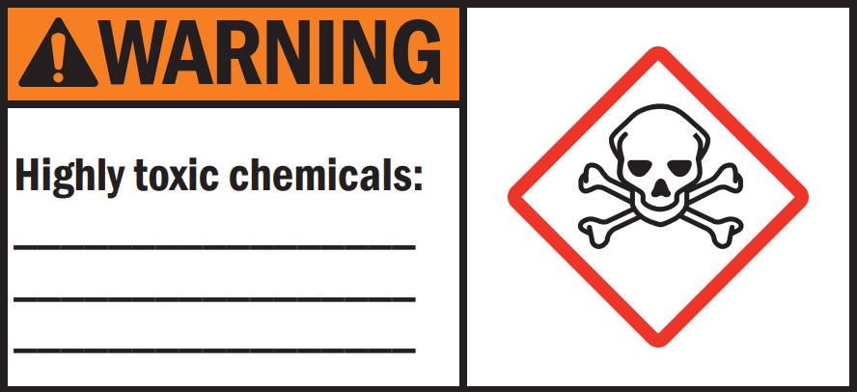

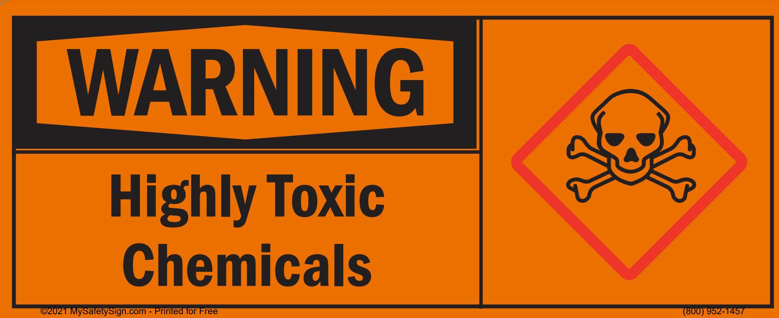

Certification

I have read and understand the above SOP. I have received approval from my Lab Director to perform this procedure. I agree to contact my Lab Director if I plan to modify this procedure.

NAME | SIGNATURE | UMID # | DATE

Laboratory Director | Revision Date

Major Revisions (Tracking purposes only -- Do not print as part of SOP)

DATE | REVISION
09-14-18 | EHS name and logo were added, updated the formatting, and revised the content  under Exposure/Unintended Content (AKJ).
03-04-19 | Reviewed and updated.
03-31-21 | Reviewed and updated. Suggested signage added.
07-05-22 | Reviewed and updated. Removed generic emergency response procedures.
03-14-23 | Updated SOP name from Highly Toxic Chemicals to Acutely Toxic Chemicals (BR)

