Hazard Assessment Worksheet and Risk Assessment

Date: | Employee(s) Covered:
Lab Director/PI: | Reviewed by EHS Rep:
Location:

Hazard Assessment

Identify the tasks conducted in your research space. Describe the potential hazards for these tasks and list the recommended PPE. See PPE Hazard Assessment recommendations below for examples and guidance.

Tasks | Potential Hazards | PPE Recommended

PPE Hazard Assessment & PPE Recommendations
NOTES:
Minimum PPE to work with hazardous materials, equipment, or processes is a lab coat, appropriate gloves, safety glasses and appropriate lab attire (closed toe shoes, long pants, etc.). Refer to Tables 1 & 2 below for additional eye and face protection guidance

Always consult the U-M SOP in addition to lab-specific SOP for more information. Always consult a material’s SDS for additional PPE guidance and use engineering and/or administrative controls.

Tasks & Materials | Potential Hazard(s) | PPE Required
Working with small (< 1 Liter) volumes of corrosive liquids | - Splash hazards  - Skin and eye damage | - Safety goggles (if splash hazard)  - Chemical resistant gloves (refer to Corrosives SOP)
Working with large (> 1 Liter) volumes of corrosive liquids, acutely toxic corrosives or work which may create a splash hazard | - Large surface area skin and eye damage  - Poisoning  - Great potential for eye and skin damage | - Safety goggles  - Face shield  - Chemical resistant gloves (refer to Corrosives SOP)  - Chemical resistant apron
Working with Hydrofluoric (HF) Acid | - Major skin damage  - Major eye damage  - Potential poisoning through skin absorption | - Safety goggles  - Chemical resistant gloves (refer to HF SOP)  - Chemical resistant apron  ** Have unexpired Calcium Gluconate on-hand **
Working with small (< 1 Liter) volumes of organic solvents | - Skin damage  - Eye Damage  - Slight poisoning potential through skin absorption | - Safety goggles (if splash hazard)  - Chemical resistant gloves (refer to Glove Compatibility Charts & SDS)
Working with large (> 1 Liter) volumes of organic solvents, very dangerous organic solvents or work which may create a splash hazard | - Major skin damage  - Major eye damage  - Poisoning through skin absorption | - Safety goggles  - Face shield  - Chemical resistant apron  - Chemical resistant gloves (refer to Glove Compatibility Charts & SDS)
Working with small (< 1 Liter) volumes of pyrophoric materials | - Body damage from burns  - Fires | - Fire resistant (FR) lab coat  - Safety goggles  - Fire/chemical resistant gloves (refer to Pyrophoric SOP)  ** No synthetic clothing allowed **
Working with large (> 1 Liter) volumes of pyrophoric materials | - Major body damage from burns  - Fires | - Fire resistant (FR) lab coat  - Safety goggles  - Fire/chemical resistant gloves (refer to Pyrophoric SOP)  ** No synthetic clothing allowed **
Working with small (< 1 Liter) volumes of human blood, body fluids or other Bloodborne Pathogens (BBP) | - Acquire an infectious disease (BBP)  - Spread of infectious disease | - Light latex or nitrile gloves

Tasks & Materials | Potential Hazard(s) | PPE Required
Working with large (> 1 Liter) volumes of human blood, body fluids or other Bloodborne Pathogens (BBP) and/or splash hazards | - Greater risk of acquiring an infectious disease (BBP)  - Greater risk of spreading an infectious disease | - Light latex or nitrile gloves  - Safety goggles  - Face shield  - Foot covers (as applicable)  - N-95 respirator (as applicable)
Working with hazardous powders | - Skin damage  - Eye damage  - Poisoning through skin absorption | - Safety goggles for large quantities  - Light chemical resistant gloves (refer to Glove Compatibility Charts)
Working with acutely toxic hazardous powders | - Greater risk for skin damage  - Greater risk for eye damage  - Greater risk for poisoning through skin absorption | - Safety goggles  - Heavy resistant gloves  - Chemical resistant apron  - Booties (as applicable)  - Also refer to Highly Toxic Chemicals SOP
Working with radioactive materials | - Cellular damage  - Spread of radioactive materials | - Safety goggles (if splash hazard)  - Light latex or nitrile gloves
Working with radioactive chemicals, e.g., corrosives, solvents, powders, etc. | - Refer to appropriate chemical sections above  - Cellular damage  - Spread of radioactive materials | - Safety goggles (if splash hazard)  - Light chemical resistant gloves  - Use PPE for applicable tasks above
Working with radioactive human blood, body fluids or other BBPs | - Cellular damage  - Spread of radioactive materials  - Risk of acquiring an infectious disease (BBP) | - Safety goggles (if splash hazard)  - Light latex or nitrile gloves
Working with cryogenic liquids | - Major skin damage  - Major tissue damage  - Major eye damage | - Safety goggles for large volumes or splash hazards  - Thicker insulated gloves  - Also refer to Cryogenic Materials SOP
Working with very cold materials and equipment, e.g., freezers, dry ice | - Skin damage | - Insulated gloves  - Also refer to Environmental Rooms SOP
Working in cold environments, e.g., walk-in cold rooms or freezers | - Frostbite  - Hypothermia | - Insulated gloves and warm clothing  - Also refer to Environmental Rooms SOP
Working with hot liquids, equipment and/or open flames, e.g., autoclave, Bunsen burner, waterbath, oil bath | - Skin damage  - Eye damage | - Safety goggles for large volumes or splash hazards  - Insulated gloves
Working with large volumes of hot, cold, or cryogenic liquids | - Major skin and eye damage Frozen or burned body tissues | - Safety goggles  - Face shield  - Heavy insulated gloves  - Chemical apron  - Also refer to Cryogenic Materials SOP

Tasks & Materials | Potential Hazard(s) | PPE Required
Working with Ultraviolet (UV) Radiation | - Conjunctivitis  - Corneal eye damage  - Erythema | - UV face shield  - Safety goggles  - Also refer to UV Radiation SOP
Working with LASER radiation | - Retinal eye damage  - Skin damage | - Appropriate shaded goggles with optical density based on individual beam parameters.  - Also refer to the EHS LASER Guideline  ** No jewelry or reflective items allowed **
Working with Infrared (IR) emitting equipment, e.g., glass blowing | - Cataracts and flash burns to cornea | - Appropriate shaded goggles
Arc/TIG welding | - Conjunctivitis  - Corneal eye damage  - Erythema | - Appropriate shaded goggles and face shield  - Work gloves
Instrument or equipment repair/service | - Eye damage from foreign objects | - Safety glasses with side shields or safety goggles  ** No loose clothing or jewelry **
Metalworking/Woodworking shop | - Eye damage from foreign objects | - Safety glasses with side shields or safety goggles  ** No loose clothing or jewelry **
Glassware washing | - Skin lacerations | - Heavy rubber gloves
Working in Industrial lab with potential injury from falling equipment or tools, e.g., Earthquake lab, Structural Engineering lab, etc. | - Head injury  - Foot injury | - Hard-hat  - Steel toe boots
Spill clean-up | - See potential hazards for applicable task section | See applicable individual task section
Changing Cryostat knife blade | - Skin lacerations  - Risk of acquiring an infectious disease (BBP) | - Steel mesh glove

TABLE I. EYE AND FACE PROTECTION SELECTION CHART

(To be used as a guide to select the proper eye and face protection.)

TYPE | HAZARD(S) | ASSESSMENT SEE NOTE (1) | PROTECTOR TYPE  (refer to graphic  below) | PROTECTORS | LIMITATIONS | NOT RECOMMENDED
I M P A C T | Chipping, grinding, machining, masonry, work, riveting, and sanding | Flying fragments, objects, large chips, particles, sand, dirt, etc. | B, C, D, E, F,  G, H, I, J, K, L, N | Spectacles, goggles, face shields  SEE NOTE (1) (3) (5) (6)  (10)  For severe exposures add N. | Protective devices do not provide unlimited protection.  SEE NOTE (7) | Protectors that do not provide protection from side exposure  SEE NOTE (10)  Filter or tinted lenses that restrict light transmittance, unless it is determined that a glare hazard exists. Refer to OPTICAL RADIATION
H E A T | Furnace operations, pouring, casting, hot dipping, gas cutting, and welding | Hot sparks | B, C, D, E, F,  G, H, I, J, K, L, N | Face shields, goggles, spectacles  *For severe exposure add N.  SEE NOTE (2) (3) | Spectacles, cup and cover type goggles not provide unlimited protection.  SEE NOTE (2) | Protectors that do not provide protection from side exposure
 |  | Splash from  molten metals | *N | *Face shields worn over  goggles H, K | ---
 |  | High temperature exposure | N | Screen face shields, reflective face shields  SEE NOTE (2) (3) | SEE NOTE (3)
C H E M I C A  L | Acid & chemicals handling, degreasing, plating | Splash | G, H, K,  *N | Goggles, eyecup, and cover types  * For severe exposure, add N. | Ventilation should be adequate but well protected from splash  entry. | < None >
 |  | Irritating mists | G | Special purpose goggles | SEE NOTE (3)

D U S T | Woodworking, buffing, general dusty conditions | Nuisance dust | G, H, K | Goggles, eyecup, and cover types |  | Atmospheric conditions and the restricted ventilation of the protector can cause lenses to fog. Frequent cleaning may  be required. | < None >
O P T I C A L  R A D I A T I O N |  |  |  | TYPICAL |  | Protection from
 |  |  |  | FILTER |  | optical
 |  |  |  | LENS |  | radiation is
 |  |  |  | SHADE | PROTECTORS | directly related
 |  |  |  |  | Welding | to filter lens | Protectors that do
 | Welding: Electric Arc |  | O, P, Q | 10 – 14 | Helmets or Welding  Shields | density.  SEE NOTE (4) | not provide  protection from optical radiation.
 |  |  |  |  |  | Select the | SEE NOTE (4)
 |  |  |  | SEE NOTE (9) |  | darkest shade  that allows
 |  |  |  |  |  | adequate task
 |  |  |  |  |  | performance.
 | Welding:
 |  |  |  |  | Welding
 | Gas |  |  | 4 – 8 | Goggles
 | Cutting |  | J, K, L, M, N, O, P, Q | 3 – 6 | or
 |  |  |  |  | Welding
 |  |  |  |  | Shields
 | Torch Brazing |  |  | 3 – 4 |  | SEE NOTE (3)
 |  |  |  |  | Spectacles
 | Torch Soldering |  | B, C, D, E, F, N | 1.5 – 3 | or |  | < None >
 |  |  |  |  | Welding Face
 |  |  |  |  | shield
 |  |  |  |  |  | Shaded or
 | Glare |  | A, B | Spectacle  SEE NOTE (9) (10) |  | special Purpose lenses as suitable
 |  |  |  |  |  | SEE NOTE (8)

NOTES TO TABLE I (ABOVE) EYE AND FACE PROTECTION SELECTION CHART:
- Care should be taken to recognize the possibility of multiple and simultaneous exposure to a variety of hazards. Adequate protection against the highest level of each of the hazards should be provided. Protective devices do not provide unlimited protection.
- Operations involving heat may also involve light radiation. As required by the standard, protection from both hazards must be provided.
- Face shields should only be worn over primary eye protection (spectacles or goggles).
- As required by the standard, filter lenses must meet the requirements for shade designations in Table II. Tinted and shaded lenses are not filter lenses unless they are marked or identified as such.
- As required by the standard, persons whose vision requires the use of prescription (Rx) lenses must wear either protective devices fitted with prescription (Rx) lenses or protective devices designed to be worn over regular prescription (Rx) eyewear.
- Wearers of contact lenses must also wear appropriate eye and face protection devices in a hazardous environment. It should be recognized that dusty and/or chemical environments might represent an additional hazard to contact lens wearers.
- Caution should be exercised in the use of metal frame protective devices in electrical hazard areas.
- Atmospheric conditions and the restricted ventilation of the protector can cause lenses to fog. Frequent cleansing may be necessary.
- Welding helmets or face shields should be used only over primary eye protection (spectacles or goggles).
- Non-side shield spectacles are available for frontal protection only, but are not acceptable eye protection for the sources and operations listed for "impact."
- Ventilation should be adequate, but well protected from splash entry. Eye and face protection should be designed and used so that it provides both adequate ventilation and protects the wearer from splash entry.
- Protection from light radiation is directly related to filter lens density. See note (4). Select the darkest shade that allows task performance.
PROTECTOR TYPES (from Table 1 above):

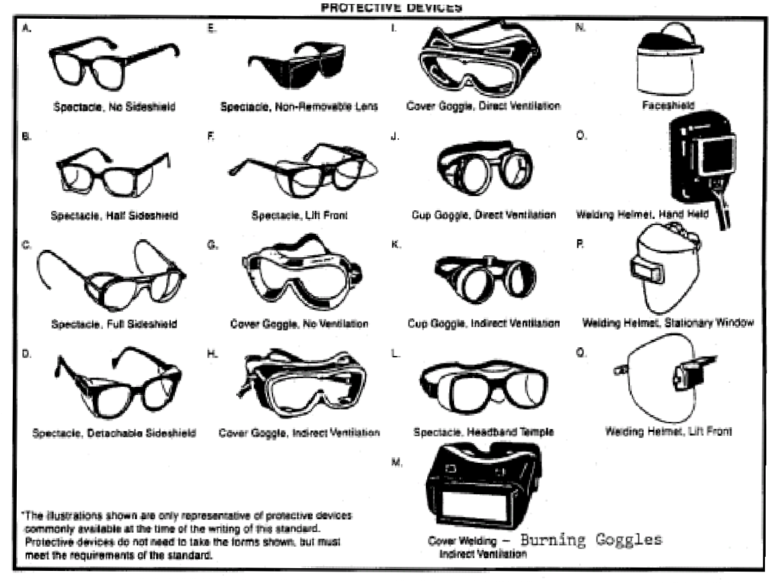

TABLE II. FILTER LENSES FOR PROTECTION AGAINST RADIANT ENERGY

(Listing of appropriate shade numbers for various operations.)

Operations | Electric Size ¹/32 in. | Arc Current  (amps) | Minimum* Protective Shade
Shielded metal arc welding | Less than 3 | Less than 60 | 7
 | 3 - 5 | 60 - 160 | 8
 | 5 - 8 | 160 - 250 | 10
 | More than 8 | 250 - 550 | 11
Gas metal arc welding and  flux cored arc welding | --- | Less than 60 | 7
 |  | 60 - 160 | 10
 |  | 160 - 250 | 10
 |  | 250 - 500 | 10
Gas Tungsten arc welding | --- | Less than 50 | 8
 |  | 50 - 150 | 8
 |  | 150 - 500 | 10
Air carbon | Light | Less than 500 | 10
Arc cutting | Heavy | 500 – 1,000 | 11
Plasma arc welding | --- | Less than 20 | 6
 |  | 20 - 100 | 8
 |  | 100 - 400 | 10
 |  | 400 - 800 | 11
Plasma arc cutting | Light** | Less than 300 | 8
 | Medium** | 300 - 400 | 9
 | Heavy** | 400 - 800 | 10
Torch soldering | --- | --- | 2
Torch brazing | --- | --- | 3
Carbon arc welding | --- | --- | 14

Operations | Plate Thickness  (inches) | Plate Thickness  (mm) | Minimum* Protective Shade
Gas Welding: | --- | --- | ---
Light | Under ¹/8 | Under 3.2 | 4
Medium | ¹/8 to ¹/2 | 3.2 to 12.7 | 5
Heavy | Over ¹/2 | Over 12.7 | 6
Oxygen Cutting: | --- | --- | ---
Light | Under 1 | Under 25 | 3
Medium | 1 to 6 | 25 to 150 | 4
Heavy | Over 6 | Over 150 | 5
* As a rule of thumb, start with a shade that is too dark to see the weld zone. Then go to a lighter shade, which gives sufficient view of the weld zone without going below the minimum. In oxyfuel gas welding or cutting where the torch produces a high yellow light, it is desirable to use a filter lens that absorbs the yellow or sodium line in the visible light of the (spectrum) operation.
** These values apply where the actual arc is clearly seen. Experience has shown that lighter filters may be used when the arc is hidden by the work piece.

Risk Assessment

According to the hazards identified above please provide the areas/locations that do not require the use of personal protective equipment (PPE) based on the assessment of risk and mitigation activities (e.g. relocation of equipment, reagents, or research procedures.)

Building | Room/Lab Space | Bay/Alcove

Refer to the Laboratory Risk Assessment Tool below for guidance on performing a laboratory risk assessment.

Clarifying Description of PPE Free Area:

Provide a description of the area in the lab where it is permissible to remove PPE. Specify what PPE may be removed in the area.

Description of Risk Mitigation:

Provide a description of processes performed in the lab from the Risk Assessment Tool. Specify the hazards and describe what is in place to protect against the hazards in the PPE Free Area e.g. barriers to protect from splash, relocation of hazards to remove them from the area, etc.

X

Lab Director/Principal Investigator (PI) / Date

Laboratory Risk Assessment Tool

The risk assessment begins by identifying the task or group of tasks that need to be evaluated. Analyze each step in the process separately to identify failure points. Then evaluate again collectively to determine if combinations of the elements could impact safety, and further review to try to predict what could go wrong to assess the impact of a safety failure.

Each procedural step must be narrowed for specific tasks such as the use of pyrophoric liquids or the use of a compressed gas. List each of these steps on the form all the way through waste generation and disposal. All procedures involving hazardous materials, potentially dangerous equipment, intermediate chemicals, and waste products should be noted (multiple pages of the tool may be necessary). You will also want to consider whether there are facility requirements for power, water, or local exhaust ventilation that are not already in place.

Next, list the chemicals and equipment that will be required in each step and assign individual hazards or potential failure points. Determine what is most likely to go wrong in each step, and the most severe consequences that can result.

A risk rating must then be determined for each of the individual hazards or potential failure points identified. There are two primary factors that determine the risk of hazards or failures associated with the use of a chemical or piece of equipment: the likelihood of that hazard or failure occurring, and the severity of the outcome. Both the likelihood and severity must be considered when determining the risk rating of hazards.

The risk rating is a semi-quantitative ranking system: low, medium, and high. A low risk rating indicates that prudent laboratory safety practices may be enough to control the hazards.
Examples of this include PPE and following proper operating procedures. A medium risk rating indicates that all control types may be necessary to control this hazard. An example of this could be a chemical procedure that requires barriers, a SOP, and work in a fume hood. A high-risk rating indicates that using all common control types may not be enough to control the hazard. If this is the case, EHS must be contacted to assist in developing an appropriate solution to controlling this hazard.

Once you know what could go wrong, determine strategies to eliminate or control the hazards. List all the controls required to abate each hazard or potential failure point. Check the Safety Data Sheets for information regarding recommended controls for chemicals and gases. Consult EHS Research Health & Safety, and see if there are others who have done similar work who can share lessons learned with you. Engineering controls must be the first option considered to mitigate hazards, followed by administrative controls and PPE. Often a combination of controls and PPE will be necessary to protect personnel in the laboratory.

The following discussion may also be helpful when conducting a risk assessment in the development of laboratory-specific SOP.

Consider the chemical process
List all possible reactions, including side reactions, before beginning. Think through all reactants, intermediates, and products in terms of flammability, toxicity, and reactivity hazards. Consider the following:
- Can hazardous chemicals be eliminated or substituted with something safer?
- Is the quantity of chemical to be used the minimum required?
- Does it decompose, and if so, how rapidly and to what products?
- What is its stability on exposure to heat, light, water, metals, etc.?
- Is it impact sensitive?
- With what substances is this material incompatible? Are any incompatible materials near the reaction?
- Is it toxic? If so, what type of hazard exists (inhalation, ingestion, skin contact)? What protective measures are required?
- What is the recommended first aid treatment in case of an accidental exposure?
- Determine the quantity and the rate of evolution of heat and gases that may be released during the reaction. Use the thermodynamic and kinetic data from the reaction chemistry.
- Are the chemicals compatible with containers and equipment?
- Will the experiment be conducted at temperatures or pressures above normal?
- Are there other hazards to be aware of such as noise, electrical, radiation, biological, or machinery?

Question the process dynamics
- How violent will it be?
- What is the effect of catalysts or inhibitors?
- How will air affect the reaction?
- How are the waste products to be handled and disposed of properly?

Develop contingency plans for
- Electric power failure
- Cooling system failure
- Exhaust system failure
- Over-pressurization
- Water leaks into system
- Air leaks into system
- Fire (Is the appropriate extinguishing agent nearby?)
- Container breakage
- Chemical spill

During the process
- Provide adequate cooling, ventilation, pressure relief, and gas purging.
- Isolate the reaction vessel, if possible, and make frequent inspections of equipment during reaction.
- Post appropriate warning signs near any dangerous equipment.
- Inform others working in the area of the chemicals in use and possible hazards.
- Always stay in the area and monitor systems that may present unusual hazards.
- Report all incidents and unusual occurrences at once.
- Follow recognized, safe practices concerning protective equipment, housekeeping, handling hazardous chemicals, and proper use of lab equipment.

List Procedure Steps | List all chemicals & equipment  in step | Hazard(s) or Potential Failure Points | Risk Rating* | List all controls required to abate each  hazard/failure point
 |  |  |  | Engineering | Adm in | PPE
1. | A. |  | Low  Medium High
 | B. |  | Low  Medium High
 | C. |  | Low Medium  High
2. | A. |  | Low Medium  High
 | B. |  | Low  Medium High
 | C. |  | Low Medium  High
3. | A. |  | Low  Medium High
 | B. |  | Low  Medium High
 | C. |  | Low Medium  High
4. | A. |  | Low  Medium High
 | B. |  | Low  Medium High
 | C. |  | Low Medium  High

5. | A. |  | Low Medium  High
 | B. |  | Low  Medium High
 | C. |  | Low Medium  High
*Consider the severity and likelihood of an incident occurring as a result of the hazards or potential failures in this step to determine risk rating.

Risk Rating  Guidance | Engineering Controls | Administrative  Controls | Personal  Protective Equipment
Low Risk: Use prudent practices to control hazards | Ventilation (fume hood, snorkel, biological safety cabinet)  Containment (glove box, reaction vessel, sealed containers, barriers)  Substitution/Elimination (consider less hazardous alternative materials)  Process controls (safety valves, gauges, temperature sensor, regulators, alarms, monitors, electrical grounding and bonding, glassware preparation). | Reduce scale of process (micro-scale experiments)  Reduce time of personal exposure to process  Provide training on proper techniques to reduce exposure and mitigate hazards | Eye and face protection (Safety glasses, safety goggles, laser eyewear face shield)  Body protection (Lab coat, apron, close-toed shoes, pants, hearing protection)  Hand protection (thermal, mechanical, chemical)  Respiratory protection (contact your EHS rep)
Medium Risk: Strongly consider all control categories for control of hazards
High Risk: Contact EHS for assistance in hazard control
Chemical expiration and testing

Equipment maintenance and certification (pressure vessel
testing)

