Name of Procedure

Exposures/Unintended Contact
Issue Date: 12/18/17
Revision #: 12/19/17
Applies To: University of Michigan departments wanting to include exposures and unintended contact procedures in their set of standard operating procedure documents.

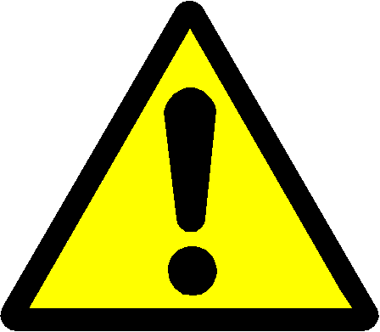
If the employee is in need of emergency medical attention, call 911 immediately.

Describe what actions to take in an exposure incident, i.e. leaving the area for inhalation hazards, removing contaminated clothing and/or PPE, flushing eyes and skin.
Contact EHS for advice on symptoms of chemical exposure, or assistance in performing an exposure assessment.

Contacting Occupational Health Services:
Describe procedures to contact Occupational Health Services for medical advice on occupational exposures.

Exposure Incident Follow Up:
Describe the procedures for completing the work related Illness and Injury Report Form.
- Report all work related accidents, injuries, illnesses or exposures to Work Connections within 24 hours by completing and submitting the Illness and Injury Report Form. Follow the directions on the Work Connections website Where to go for treatment to obtain proper medical treatment and follow-up.
- Complete the EHS Laboratory Incident and Near-Miss Report form.

