UNIVERSITY OF MICHIGAN AUTHORIZED DIVER
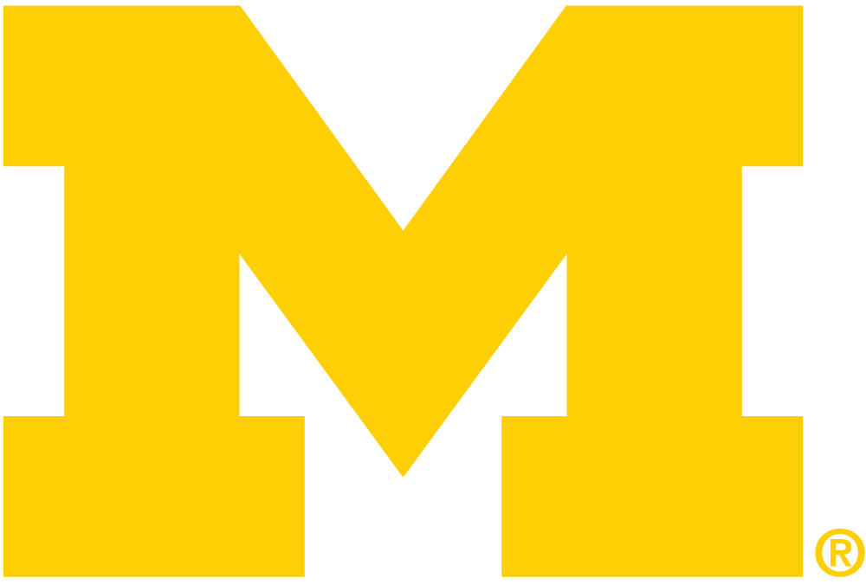
STATEMENT OF UNDERSTANDING

As an employee or student of the University of Michigan engaging in diving and/or hyperbaric chamber activities under the auspices of the University, I agree to abide by the standards and regulations established by the Diving Control Board and the Diving Safety Coordinator. I understand that these standards and regulations are necessary to meet the requirements specified by the State of Michigan and University Ocean Laboratory System as well as the American Academy of Underwater Sciences. I further understand that my diving privileges may be restricted, suspended, or revoked for failure to comply with the established standards and regulations of the University or for conduct that is considered unsafe by my supervisor, the Diving Safety Coordinator, Diving Control Board, or other authorized divers and support personnel.

I understand that it is my personal responsibility to maintain myself in good physical condition and at a high level of diving proficiency. Accordingly, I agree to:

- Abide by the standards and regulations for diving as designated by the Diving Control Board and published in the University of Michigan Occupational Safety and Health Standard for Scientific Diving Operations.

- Submit to annual medical examination for divers as prescribed by Act No. 154 of the Public Acts of 1974 as amended (Occupational health Standard).

- Attend periodic evaluation, training, and update workshops as specified by the Diving Control Board for purposes of demonstrating, maintaining, and upgrading my diving proficiency and knowledge.

- Comply with the annual re-qualification requirements as designated by the Diving Control Board and published in the University of Michigan Occupational Safety and Health Standard for Scientific Diving Operations.

- Maintain diving activity and equipment records as required by the University and State of Michigan.

- Submit an annual record of diving to the Diving Safety Coordinator.

I understand that I have the right, indeed the responsibility, to refuse to dive if, in my judgment:

- Conditions are unfavorable or unsafe for diving.

- I am experiencing physical or emotional problems that may be a contraindication to safe participation in diving.

- The diving equipment, task requirements, or environmental conditions exceed my University authorization, training, experience, or personal limitations.

- Participation in the dive would violate the dictates of proper diving safety procedures or the University’s standards or regulations.

I understand that in accepting University diver authorization I am incurring obligations for safety, training, record keeping, and adherence to specific standards and regulations as well as the inherent risks associated with diving, swimming, and hyperbaric chamber activities and a potential lack of competent medical assistance at the remote locations where dives may occur. I willingly accept these risks and responsibilities for my actions as a diver or diving support person. I understand the Diving Safety Coordinator and the Diving Control Board will make the final judgment as to my competency to be awarded a University of Michigan Diver Authorization and I agree to abide by their decision.

By signing this form, I attest that I am of good physical condition to dive and that I will comply with all responsibilities and obligations stated and referenced above as long as I dive through the auspices of the University of Michigan.

_________________________________________ _____________________________________________
Witness Signature Date Employee/Student Signature Date

