Methylene Chloride

Standard Operating Procedure
Revision Date: 12/20/23

This standard operating procedure (SOP) outlines the handling and use of methylene chloride. Review this document and supply the information required in order to make it specific to your laboratory. In accordance with this document, laboratories should use appropriate controls, personal protective equipment, and disposal techniques when handling methylene chloride. All laboratory workers must read and understand the Laboratory Emergencies SOP prior to commencing any work in a laboratory.

Description [Provide additional information as it pertains to your research protocol]
Methylene chloride (CAS # 75-09-2) is a colorless liquid with a mild, sweet (“chloroform-like”) odor that can be detected as low as 0.9 ppm (odor threshold). It is often used as an industrial solvent, for metal cleaning and degreasing and in various paint strippers. It may also be found in some aerosol and pesticide products and is used in the manufacture of photographic films.
Synonyms include: Dichloromethane; DCM; MeCl & MeCl_{2;} Methane dichloride; Methylene bichloride; Methylene dichloride

Useful Methylene Chloride Links
- http://www.osha.gov/pls/oshaweb/owadisp.show_document?p_table=STANDARDS&p_id=10095
- http://www.atsdr.cdc.gov/toxfaqs/tfacts14.pdf
- http://www.cdc.gov/niosh/topics/methylenechloride/

Process [Write the steps for using the chemical in your research protocol]

Potential Hazards [Provide additional information as it pertains to your research protocol]
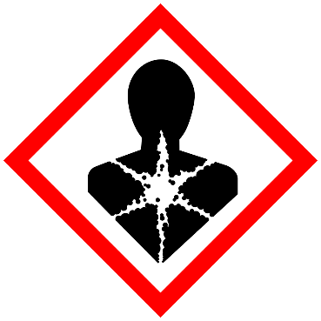
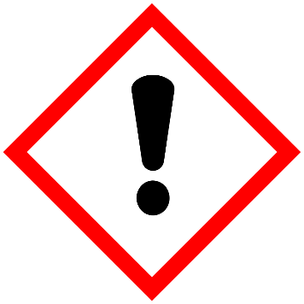
- Skin irritation (Category 2), H315
- Eye irritation (Category 2A), H319
- Carcinogenicity (Category 2), H351
- Specific target organ toxicity - single exposure (Category 3), Central nervous system, H336
1 - GHS pictograms for methylene chloride
- Methylene chloride exposure can cause adverse health effects to the central nervous system (CNS), liver, and cardiovascular system including mental confusion, light-headedness, nausea, vomiting and headache.
- It is metabolized by the body to carbon monoxide, and therefore reduces the blood’s ability to transport oxygen. It is also a suspected carcinogen.
- Exposure may also cause eye and respiratory tract irritation.
- Skin exposure to liquid may cause irritation and skin burns after extended exposures.
- There is a substance-specific MIOSHA standard for Methylene Chloride.
- Consult the SDS for methylene chloride, U-M’s GoldFFX SDS database, as well as the links above for more information.

Occupational Exposure Limits (OELs)
- MIOSHA: 25 ppm, 8-hour PEL
- MIOSHA: 125 ppm, 15-minute STEL

Contact EHS for assistance in performing an exposure assessment.

Engineering Controls [Provide additional information as it pertains to your research protocol]
- Work with open containers of methylene chloride should be conducted only in a fume hood.
- Dilute solutions, small quantities, and closed containers of methylene chloride may be handled on the bench top.
- If it is reasonably foreseeable that an employee's eyes may contact solutions containing 0.1 percent or greater of methylene chloride, e.g., through splashes, spills or improper work practices, the MIOSHA methylene chloride standard requires eyewash facilities within the immediate area for emergency use. MIOSHA also requires that affected employees use these facilities as needed.
- If it is reasonably foreseeable that an employee’s skin may contact solutions containing 0.1 percent or greater methylene chloride, e.g., through splashes, spills or improper work practices, the MIOSHA methylene chloride standard requires conveniently located washing facilities capable of removing the methylene chloride. MIOSHA also requires that affected employees use these facilities as needed.

Work Practice Controls [Provide additional information as it pertains to your research protocol]
- Designate an area for working with methylene chloride, and label it as such.
- Keep containers closed as much as possible. Handle open containers only in a chemical fume hood.
- Use in the smallest practical quantities for the experiment being performed.
- Typical laboratory use of methylene chloride should not put employees at risk of overexposure but labs using large amounts of methylene chloride should contact Environment, Health & Safety (EHS) at (734) 647-1143 for an exposure assessment.
- Once work with methylene chloride is complete, wipe down work area with soap and water solution.
- Keep away from ignition sources. Incompatible with strong oxidizers and metals.
- Wash hands thoroughly after use. Do not eat, drink or smoke in areas where methylene chloride or other chemicals are used.

Personal Protective Equipment [Provide additional information as it pertains to your research protocol]
- Methylene chloride readily penetrates through standard nitrile, natural rubber and polyvinyl chloride laboratory gloves.
- Wear two pairs of gloves when using methylene chloride. Disposable gloves provide minimum protection for general laboratory use and should be changed frequently or whenever contamination is suspected.
- The inner glove should be made of a laminate of polyethylene (PE)/ethylene vinyl alcohol (EVOH), e.g., Silvershield®/4H by North or a laminate of Viton®/Butyl rubber, a laminate of polyethylene vinyl alcohol/ethylene vinyl alcohol (PVA/EVA), Polyvinyl Alcohol (PVA), or other laminate materials that are resistant to methylene chloride to prevent penetration through to skin.
- Based on work activities, outer gloves made of nitrile or neoprene are also recommended to prevent cuts, tears, punctures or rips to the inner methylene chloride-resistant gloves. [NOTE: Because methylene chloride can readily penetrate nitrile and neoprene, wearing just an outer glove of this material will not protect your skin from methylene chloride exposure.]
- Safety goggles should be worn when a splash hazard exists; safety glasses with side shields (both that meet the requirements of ANSI/ISEA Z87.1) are required at a minimum when methylene chloride is used in a closed system.
- A fully buttoned laboratory coat must be worn when working with chemicals. A chemically resistant apron should be used if transferring or using large quantities of methylene chloride in open containers.
- Also refer to the EHS Glove Compatibility Chart.

Transportation and Storage [Provide additional information as it pertains to your research protocol]
- Transport methylene chloride in secondary containment, preferably a polyethylene or other non-reactive acid/solvent bottle carrier.
- Keep container in cool, well-ventilated area.
- Keep container tightly closed and sealed until ready for use.
- Store in secondary containment away from moisture, strong oxidizers, strong caustics, plastics, rubber, nitric acid, water + heat, and chemically active metals, such as aluminum and magnesium powder, sodium, potassium, and lithium.
- Avoid storing on the floor.
- Avoid ignition sources.

Waste Disposal [Provide additional information as it pertains to your research protocol]
Because spent, unused, and expired methylene chloride is considered hazardous waste, it must be properly disposed of. Do not dispose of methylene chloride wastes by dumping them down a sink, flushing in a toilet or discarding in regular trash containers. Contact EHS-HMM at (734) 763-4568 for waste containers, labels, manifests, waste collection and for any questions regarding proper waste disposal. Also, refer to the EHS Hazardous Waste Web page for more information.

Training of Personnel
All personnel shall read and fully adhere to this SOP when handling methylene chloride.

Certification
I have read and understand the above SOP. I agree to contact my Lab Director if I plan to modify this procedure.
Name | Signature | UMID # | Date

Lab Director | Revision Date

Major Revisions (Tracking purposes only -- Do not print as part of SOP)
Date | Revision
09-14-18 | EHS name and logo were added, updated the formatting, and revised the content under Exposure/Unintended Content (AKJ).
02-25-19 | Updated links (DML)
05-11-22 | Removed emergency response procedures section. Updated links. (LGS)
12-20-2023 | Annual review, added GHS info (JMW)

