Environmental Rooms

Standard Operating Procedure
Revision Date: 06/03/22

This standard operating procedure (SOP) outlines the potential hazards and controls necessary when working in environmental rooms. Review and customize this document for your specific laboratory work. In accordance with this document, laboratories should use appropriate controls, personal protective equipment, and disposal techniques when working in environmental rooms.

Description [Provide additional information as it pertains to your research protocol]
Environmental Rooms are designed and engineered to provide research space with controlled temperature and/or humidity levels within specified and narrow tolerances. They are generally built for the growth of cells or organisms, reliable storage, and laboratory applications requiring precisely-controlled conditions. They are usually designed with limited or no mechanical ventilation, and are often closed air circulation systems that rely on the opening and closing of the room's door in order to bring fresh air into the room. In contrast, a typical laboratory has 6 to 10 air exchanges per hour of outside air through the building ventilation system.

Process [Write the steps for using the chemical in your research protocol]

Potential Hazards [Provide additional information as it pertains to your research protocol]
Because environmental rooms have limited or no mechanical ventilation, the release of any toxic substance into an environmental room presents greater hazards to occupants, and could result in the potential cross-contamination of research projects.
Unabated mold growth within an environmental room may lead to mycological contamination of storage areas, materials, or research projects and pose potential health problems from the inhalation of mold spores. Spores can also be tracked out of the room and around the entire floor of the building. Minimizing mold growth requires the control of moisture, e.g., standing/leaking water and/or high humidity, limiting the presence of organic materials, and good housekeeping in the environmental room.
Evaluate the possible hazards of the materials and processes you intend to use or store within an environmental room before you begin your work or storage of any materials. Of extra concern are gases, cryogenic liquids, volatile compounds, and any inhalation hazards. Hazard information including potential route(s) of exposure and under what conditions an exposure might occur should be detailed in this section.
General guidelines and recommendations for the safe handling, use and control of hazardous chemicals and particularly hazardous substances can be found in a chemical’s SDS and in other chemical hazard references. Pay particular attention to chemical properties, e.g., flammable, corrosive, toxic, carcinogenic, pyrophoric, irritant, etc., as well as any incompatibilities, in order to determine if a material can be worked with or stored within an environmental room.
In addition to the potential chemical and physical hazards in environmental rooms, walk-in refrigeration units are prone to mold growth due to high humidity levels. Mold can be a respiratory irritant to those with sensitivity as well as a financial burden if an excessive buildup occurs and professional remediation is required. This procedure outlines good housekeeping and work practices to minimize the presence of visible mold. See example pictures of mold-growth in cold rooms below:
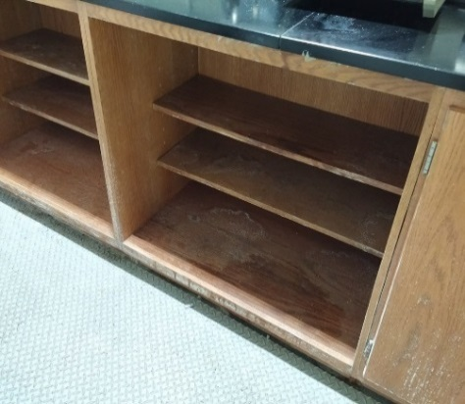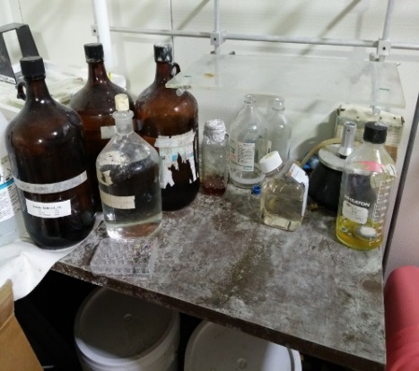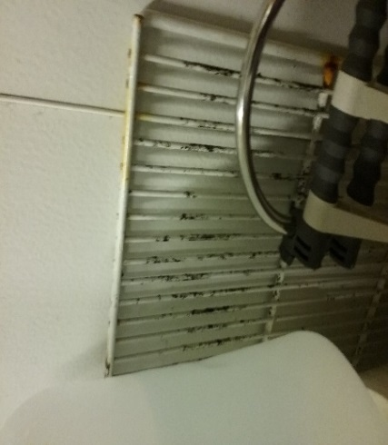
Indoor mold growth can have adverse health effects that include:
- Hay fever-like allergic symptoms, runny nose, itchy, burning eyes etc.
- Aggravation of existing asthma or other respiratory disorders.
- Increased risk of infection, especially in immune suppressed individuals
Stop work and see a physician if you experience any of these symptoms.

Environmental Room Door Markings
Many environmental rooms are designed like a large refrigerator that only recirculates air; they do not have a fresh air supply or exhaust ducts to ventilate the space. As an aide to remind individuals of this design feature and potential hazard in environmental rooms, Environment, Health & Safety (EHS) has stickers that can be placed on the door to the room (shown below). If you are interested in obtaining the sticker please contact your EHS representative or the EHS main office at (734) 647-1143.

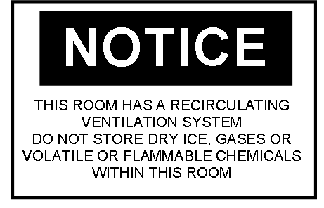

Engineering Controls [Provide additional information as it pertains to your research protocol]
Due to limited or no mechanical ventilation, do not conduct work with or store the following materials and equipment in environmental rooms:
- Particularly Hazardous Chemicals, i.e., highly acutely toxic chemicals, carcinogens, reproductive toxins: Can result in personnel exposure due to the lack of exhaust ventilation.
- Volatile Flammable Solvents: Exposed circulation fan motors and electrical lab equipment are potential ignition sources.
- Volatile Acids: Can corrode coiling coils in refrigeration systems.
- Asphyxiants, e.g., compressed gases such as nitrogen or carbon dioxide: May displace oxygen due to limited ventilation rate, resulting in an oxygen-deficient environment.
- Dry Ice: An oxygen-deficient environment can occur from the release of carbon dioxide gas.
- Open Flame, e.g., Bunsen burners.
- Food or Beverage: They can become contaminated by chemicals or biological organisms.
- Corrosives
Because hazardous vapors and fumes are not actively removed from the environmental room environment, work involving any hazardous materials should be done only in closed systems.
Take great care to control hazards and ensure a safe working environment:
- Prevent the release of gases, fumes or aerosols at all times.
- Use a less hazardous product that can perform the same task, if possible.
- Use the smallest possible quantities.
Consider if liquid form reagents would be less hazardous than powder and, if so, purchase in liquid form. If possible, indicate that the chemical will be purchased in small quantities or dilute solutions to reduce the risk of exposure and minimize waste.

Work Practice Controls [Provide additional information as it pertains to your research protocol]
- Keep doors firmly shut – if left open, water condensation on surfaces increases due to high relative humidity, promoting mold growth.
- Immediately clean up spilled laboratory liquids, e.g., buffers and media. Moisture may lead to rust, corrosion or degradation of environmental room integrity, e.g., shelves.
- Promptly dispose of wet or damp materials.
- Store paper & porous materials, e.g., Kimwipes, cardboard, blotting paper, etc., in closed, air-tight, plastic containers. Do not use cardboard boxes or other absorptive materials as storage containers in environmental rooms, unless relative humidity (RH) levels are maintained at very low levels, e.g., <20%.
- Implement a monthly (at minimum) cleaning schedule of all surfaces within the cold room. Wipe down metal surfaces using a 70% ethanol solution (to avoid pitting of metal) and all other surfaces using a 1:10 dilution mixture of household bleach. Make sure all surfaces are wiped dry of excess cleaning solution using a dry cloth.
- Surfaces to be cleaned include:
  - Interior and exterior surfaces of cabinetry
  - Countertops, work benches, and table surfaces
  - Inside of door
  - Department-owned equipment and associated parts
  - Floors
  - Light switches
  - Shelves
  - Sinks
  - Walls, including white, powdery substance that can be mistaken for oxidation
  - Window
- DO NOT WET WIPE ELECTRICAL FIXTURES / OUTLETS. UNPLUG ALL ELECTRICAL EQUIPMENT.
- Promptly remove and discard mold-contaminated items in a sealed plastic bag (no special disposal is required).
- Consider implementing a cleaning history log for cold rooms (see last page.)
- If the unit will be shut down for more than 24 hours, thoroughly clean and then keep doors open (allowing to dry) until the unit is put back in service.
- Report all plumbing leaks, faulty latch/door seal, inconsistent temperatures or lighting issues or electrical problems to the Facilities Service Center at 647-2059.
In instances where heavy mold contamination is detected, please contact EHS at 647-1143 for a consultation to determine whether professional cleaning services are necessary.
NOTE: Because molds grow best in a humid environment ≥ 60% relative humidity (RH) and at temperatures between 77°F and 86°F, it is best to maintain the air as cool (65°F – 75°F) and dry (< 20% RH) as possible, so as to minimize conditions for mold growth.
Also, refer to the EHS Mold Web page.

Personal Protective Equipment [Provide additional information as it pertains to your research protocol]
Always wear personal protective equipment (PPE) when performing cleaning activities, including lab coat, gloves and eye protection. Note: sensitivity to mold can vary. Contact EHS for advice regarding respiratory protection while cleaning.

Waste Disposal [Provide additional information as it pertains to your research protocol]
Most spent, unused and expired materials are considered hazardous wastes. Contact the EHS Hazardous Materials Management (HMM) Group at 763-4568 for waste containers, labels, manifests, waste collection and for any questions regarding proper waste disposal. Also refer to the EHS Hazardous Waste Web page for more information.

Training of Personnel
All personnel are required to complete the General Laboratory Safety Training session (BLS025w or equivalent) via EHS’s My LINC Web site. Furthermore, all personnel shall read and fully adhere to this SOP when working in environmental rooms.

Certification
I have read and understand the above SOP. I agree to contact my Lab Director if I plan to modify this procedure.
Name | Signature | UMID # | Date

Laboratory Director | Revision Date

Monthly Cold Room Cleaning Log
Wipe down metal surfaces using a 70% ethanol solution (to avoid pitting of metal) and all other surfaces using a 1:10 dilution mixture of household bleach. Make sure all surfaces are wiped dry of excess cleaning solution using a dry cloth.
- Surfaces to be cleaned include:
  - Interior and exterior surfaces of cabinetry
  - Countertops, work benches, and table surfaces
  - Inside of door
  - Department-owned equipment and associated parts
  - Floors
  - Light switches
  - Shelves
  - Sinks
  - Walls, including white, powdery substance that can be mistaken for oxidation
  - Window
- Remove and discard mold-contaminated items in a sealed plastic bag (no special disposal is required).
- Report all plumbing leaks, faulty latch/door seal, inconsistent temperatures or lighting issues or electrical problems to Facilities Service Center at 647-2059.
Date | Name/Lab | Comments
01/30/2023 | Jane Smith, Brown Lab | Cleaned, called in work order to fix door seal

Major Revisions (Tracking purposes only – Do not print as part of SOP)
Date | Revision
11-16-2016 | Added general information on mold hazards, work practices for mold (AKJ).
09-07-18 | Added symptoms of mold exposure in Potential Hazards section (JL).
09-14-18 | EHS name and logo were added, updated the formatting, and revised the content under Exposure/Unintended Content (AKJ).
03-04-19 | Reviewed and updated.
06-03-22 | Removed emergency response information and updated (LGS)

