Carcinogens
Standard Operating Procedure
Revision Date: 6/6/2022

Laboratory Director (LD) Approval is Required Prior to Performing this Procedure
This standard operating procedure (SOP) is designed to provide guidance in writing procedures for the safe handling and disposal of carcinogens, which are regarded as particularly hazardous substances. Review this document and supply the information required in order to make it specific to your laboratory.

Description [Provide additional information as it pertains to your research protocol]

MIOSHA defines a select carcinogen as any substance meeting one the following:
- It is regulated by OSHA as a carcinogen
- It is listed under the category, “known to be carcinogens” in the latest National Toxicology Program annual report.
- It is listed under Group 1 by the International Agency for Research on Cancer (IARC).
- It is listed in Group 2A or 2B by IARC or under the category, “reasonably anticipated to be carcinogens” by NTP, and causes statistically significant tumor incidence in experimental animals in accordance with any of the following criteria:
  - After inhalation exposure of 6-7 hours per day, 5 days per week, for a significant portion of a lifetime to dosages of less than 10 mg/m3.
  - After repeated skin application of less than 300 mg/kg of body weight per week.
  - After oral dosages of less than 50 mg/kg of body weight per day.
For practical purposes, U-M Laboratories may utilize Globally Harmonized System (GHS) hazard categories to perform hazard classifications for carcinogenicity. Categories 1A, 1B, and 2 for the Carcinogenicity hazard class are approximately equivalent to the bulleted criteria above.
If you have questions concerning the applicability of any item listed in this procedure contact the LD/Laboratory Supervisor or Environment, Health & Safety (EHS) at (734) 647-1143.

Process [Write the steps for using the chemical in your research protocol]

Potential Hazards [Provide additional information as it pertains to your research protocol]

A carcinogen commonly describes any agent that can initiate or speed the development of malignant or potentially malignant tumors, malignant neoplastic proliferation of cells, or cells that possess such material.

Engineering Controls [Provide additional information as it pertains to your research protocol]

- Manipulation of carcinogens should be carried out in a fume hood. If the use of a fume hood proves impractical refer to the section on special ventilation.
- Certain carcinogens must be handled in a glove box rather than a fume hood. EHS (734) 647-1143 or the LD will determine if this is required.
- Where the eyes or body of any person may be exposed to carcinogens, suitable facilities for quick drenching or flushing of the eyes and body shall be provided within the work area for immediate emergency use. Bottle type eyewash stations are not acceptable.
- Safety shielding is required any time there is a risk of explosion, splash hazard or a highly exothermic reaction. All manipulations of carcinogens which pose this risk should occur in a fume hood with the sash in the lowest feasible position. Portable shields, which provide protection to all laboratory occupants, are acceptable.
- Manipulation of carcinogens outside of a fume hood may require special ventilation controls in order to minimize exposure to the material. Fume hoods provide the best protection against exposure to carcinogens in the laboratory and are the preferred ventilation control device. When possible, handle carcinogens in a fume hood. If the use of a fume hood proves impractical, attempt to work in a glove box or on an isolated area on the bench top.
- If available, consider using a Biological Safety Cabinet. The biological safety cabinet is designed to remove particulates (the carcinogen) before the air is discharged into the environment. Carcinogens that are volatile must not be used in a biological safety cabinet unless the cabinet is vented to the outdoors.
- If your research does not permit the handling of carcinogens in a fume hood, biological safety cabinet, or glove box, you must contact EHS.
- Evacuated glassware can implode and eject flying glass, and splattered chemicals. Vacuum work involving carcinogens must be conducted in a fume hood, glove box or isolated in an acceptable manner.
- Mechanical vacuum pumps must be protected using cold traps and, where appropriate, filtered to prevent particulate release. The exhaust for the pumps must be vented into an exhaust hood.

Work Practice Controls [Provide additional information as it pertains to your research protocol]

Lab directors must designate where in the laboratory work with carcinogens is permitted. Work involving carcinogens should include use of engineering controls whenever possible (see engineering controls section). A designated area may include the engineering control device (i.e. fume hood, glove box, etc.) or a specified lab or bench space.

All areas where carcinogens are manipulated outside of a container or containment device must be labeled as a designated area.

- Contact EHS prior to using any carcinogen outside of a fume hood, vented biological safety cabinet, or glove box
- Designated area signage templates are included at the end of the SOP document.

- All employees with access to designated areas must be made aware of the substances being used and necessary precautions by the LD.

- Where feasible, carcinogens should be manipulated over plastic-backed disposable paper work surfaces. These disposable work surfaces minimize work area contamination and simplify clean up.

In the space below, describe in detail the designated areas in your laboratory for work involving carcinogens. For labs with multiple designated areas, it may be helpful to attach an illustration of the laboratory.

Containers
All containers of carcinogens must be clearly labeled with the correct chemical name. Handwritten labels are acceptable; chemical formulas and structural formulas are not acceptable.
Wash hands, forearms, face, and neck upon exit of a designated area to decontaminate.

Record
Your laboratory’s chemical inventory should include accurate records of carcinogenic substances in use and in storage. Record dates of use and names of researchers using the substances.

Personal Protective Equipment [Provide additional information as it pertains to your research protocol]

Eye protection in the form of safety glasses must be worn at all times when handling carcinogens. Adequate safety glasses must meet the requirements of the Practice for Occupational and Educational Eye and Face Protection (ANSI Z87.1) and must be equipped with side shields. Safety glasses with side shields do not provide adequate protection from splashes; therefore, when the potential for splash hazard exists, other eye protection and/or face protection must be worn.
Gloves must be worn when handling carcinogens. Disposable nitrile gloves provide adequate protection against accidental hand contact with small quantities of most laboratory chemicals. Lab workers should contact EHS for advice on chemical resistant glove selection when direct or prolonged contact with hazardous chemicals is anticipated.
Lab coats, closed toed shoes and long sleeved clothing must be worn when handling carcinogens. Additional protective clothing should be worn if the possibility of skin contact is likely.

Waste Disposal [Provide additional information as it pertains to your research protocol] Because most spent, unused, and expired chemicals/materials are considered hazardous wastes, they must be properly disposed of. Do not dispose of chemical wastes by dumping them down a sink,

flushing in a toilet or discarding in regular trash containers, unless authorized by EHS Hazardous
Materials Management (HMM). Contact EHS-HMM at (734) 763-4568 for waste containers, labels, manifests, waste collection and for any questions regarding proper waste disposal. Also refer to the EHS Hazardous Waste Web page for more information.

Training of Personnel

All personnel shall read and fully adhere to this SOP when handling carcinogens.

Suggested Signage

The signs below may be printed for use in the laboratory to label designated use or storage areas. Resize images as needed for printing.

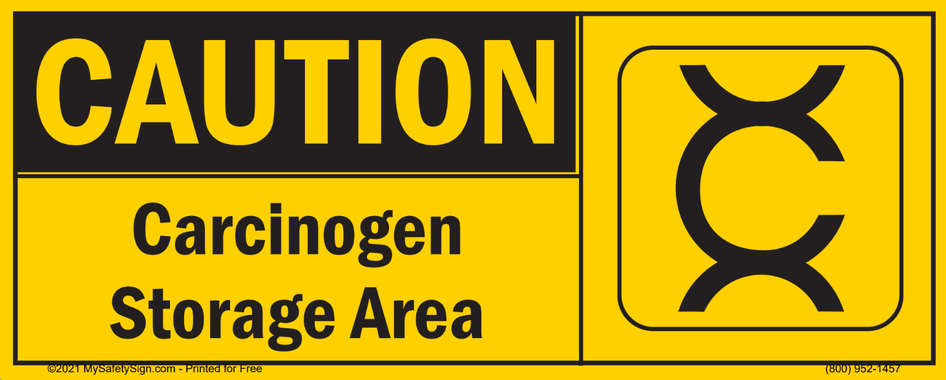

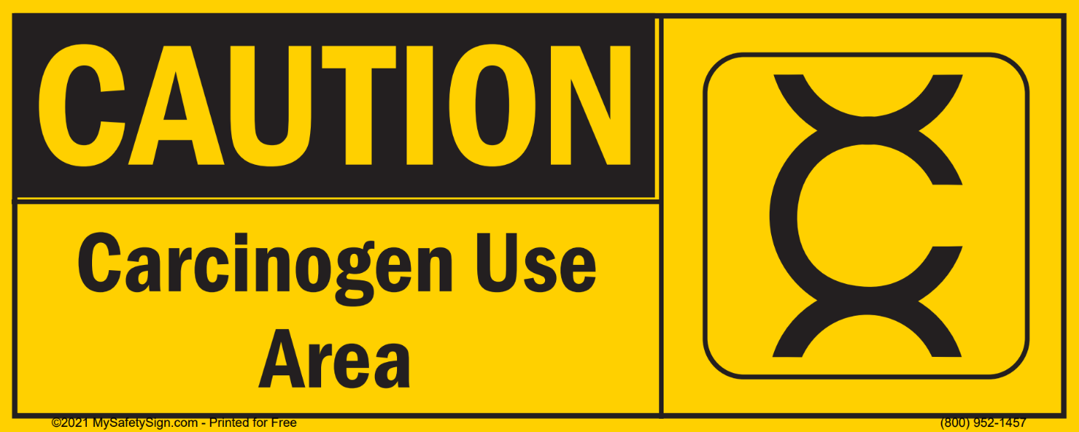

Certification

I have read and understand the above SOP. I agree to contact my Lab Director if I plan to modify this procedure.

NAME | SIGNATURE | UMID # | DATE

Laboratory Director | Revision Date

Major Revisions (Tracking purposes only -- Do not print as part of SOP)

DATE | REVISION
09-13-18 | EHS name and logo were added, updated the formatting, and revised the content  under Exposure/Unintended Content (AKJ).
03-04-19 | Reviewed and updated.
03-31-21 | Reviewed and updated. Suggested signage added.
08-17-22 | Content review, Removed emergency info (JMW)

